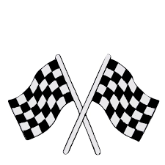Locomotor Speedway
Locomotor movements are ways in which the body travels through space from one location to another.
The six most common locomotor movements are:
Walking
Running
Skipping
Galloping
Hopping
Jumping

Mark off a large oval/circle in your yard or driveway to be used as a track. Use toys, shoes or landmarks in the yard if needed.
Directions:
- Perform one lap around the track for each locomotor movement listed above. 6 laps total
- Use a timer to see how fast you can complete all 6 laps
- Can you rearrange the movements above to beat your time?
- Can you come up with 6 new locomotor movements and beat your time?
- Can you race and beat a sibling or parent?

